**Assignment 8.1 Advance Hive**

Employee

Name , Dept, Salary

A,Fin,900

D,Fin,1000

H,Fin,1100

K,Fin,1200

B, HR,900

C, HR,800

E, HR,1100

F,HR,1200

**Problem Statement**

* List of all employees who draw higher salary than the average salary of that department

**Step 1:**

Create table Emp_Sal (name string, dept string,sal int) row format delimited fields terminated by ',' stored as textfile;

Describe Emp_Sal;

**Step 2:**

load data local inpath '/home/cloudera/employee.txt' into table Emp_Sal;

**Step 3:**

Select dept, sal_a,sal_b from (

SELECT a.dept, a.sal sal_a,b.sal sal_b FROM emp_sal a LEFT Outer JOIN (SELECT dept, Avg(sal) sal FROM emp_Sal GROUP BY Dept) b on (a.dept = b.dept) ) b

Where sal_a > sal_b;

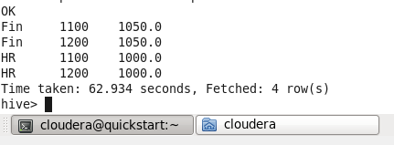

**Problem Statement :2**

Get a list of employees who receive a salary less than 100, compared to their immediate employee with higher salary in the same unit

Select name,dept, sal_a,sal_b from (

SELECT a.name,a.dept, a.sal sal_a,b.sal sal_b FROM emp_sal a LEFT Outer JOIN (SELECT name,dept, Max(sal) sal FROM emp_Sal GROUP BY Dept,name) b on (a.dept = b.dept) ) b

Where (sal_b -100) = sal_a;

